35.22: a) The source separation is 9.00 m, and the wavelength of the wave is 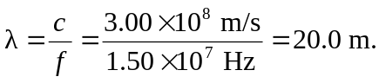 So there is only one antinode between the sources 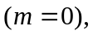 and it is a perpendicular bisector of the line connecting the sources.

b) 